**Install IBM Cloud****CLI**

**Step 1:**

Login to your IBM Cloud [***https://cloud.ibm.com/login*** an](https://cloud.ibm.com/login)d in-search bar you can type Container registery and click to get started.

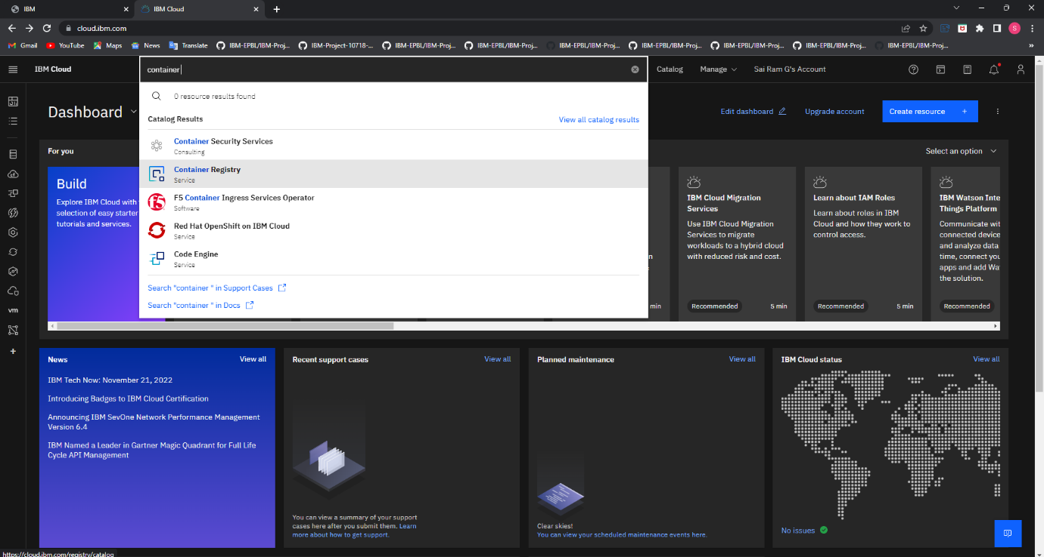

**Step2:**

**Step 3:**

Run the command in power shell,

***(NewObjectNet.WebClient).DownloadString('https://clis.cloud.ibm.cm/instal l/powershell')***

**Step 4:**

Enter the command in cmd prompt:

**Step 5:**

Run all the command one by one in cmd[***https://cloud.ibm.com/docs/containers?topic=containers-cs_cli_install***](https://cloud.ibm.com/docs/containers?topic=containers-cs_cli_install)

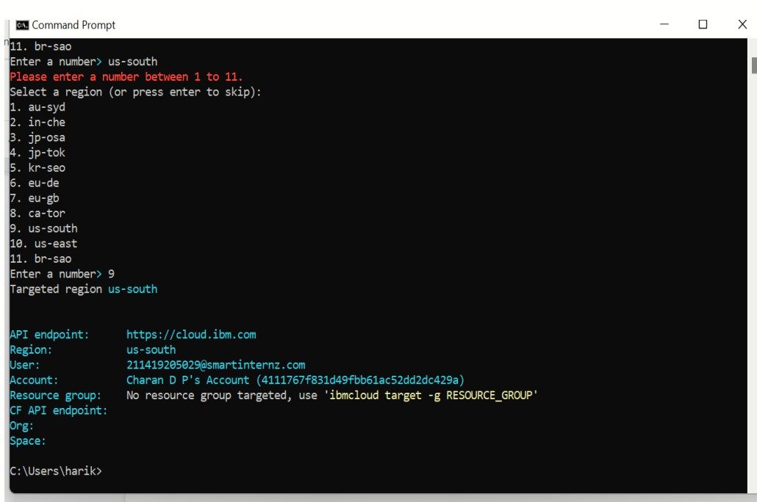

**Step 6:**

Finally, you will get the IBM CLOUD CLI in your desktop.